HONG KONG VETERANS ASSOCIATION and HONG KONG VETERANS COMMEMORATIVE ASSOCIATION

GENERAL MEETING

OTTAWA, ON
AUGUST 13, 2005

The meeting opened with the singing of O Canada and the HKVCA opening protocol. George Peterson recited the Act of Remembrance in English, and Phil Doddridge in French. The Rev. Vicky Hedelius offered a prayer.

Call to order Carol Hadley, National President of the HKVCA, called the meeting to order at 9:20am.

Welcome John Stroud, President of the Ontario HKVA, and Pat Turcotte, HKVCA Ontario Regional Director, welcomed the attendees to the convention and thanked the convention organizing committee for their hard work. Rob Jellett, Deputy Mayor of Ottawa, welcomed the delegates on behalf of the Mayor and City of Ottawa.

Minutes of last general meeting Mike Babin, Recording Secretary pro tem, read the minutes.

Adoption of minutes A motion to adopt the minutes was made by Don Thomson and seconded by Ross Purse. CARRIED

Business arising from minutes There was no business arising from the minutes.

Treasurer’s report Barry Mitchell, HKVCA Treasurer, outlined the Association’s financial reporting process and presented the highlights of the audited financial statement for 2004 (as of December 2004 year-end). Copies were made available to the attendees, and a copy is attached to these minutes. A motion to accept the report was made by Barry Mitchell and seconded by Bob Lytle. CARRIED

Correspondence A memo received from the War Amps regarding the Veterans Wall of Remembrance was read by the Secretary. A copy is attached, and the information has also been posted on the HKVCA web site.

Administrative matters Carol Hadley reviewed several administrative matters related to the convention.

Reports of the National Presidents
- Phil Doddridge, president of the HKVA, reported on the HKVA annual meeting held Aug. 11, 2005. He advised that at that meeting a motion was passed to re-endorse Cliff Chadderton, CEO of the War Amps, as the HKVA patron.

- Carol Hadley thanked the convention committee, VAC and volunteers for their hard work in organizing the convention. She introduced the members of the national executive, reviewed the accomplishments of the HKVCA since the last general meeting and outlined the goals of the HKVCA. A copy of her report is attached.

New business
- George Peterson asked why the HKVA Colour Party would not be allowed to march in the commemoration ceremony at the Cenotaph on Aug. 14. Carol Hadley and Derrill Henderson provided an explanation.
- John Stroud discussed the reports of prisoners poisoned in the camps in Hong Kong and asked if anyone could provide further information. There was some discussion on the topic. John also recognized the formation of the first HKVA branch (Ontario) in 1948.
- Vince Lopata offered to hold a supplementary presentation on the proposed “C” Force memorial project.

- Carol Hadley reviewed a Manitoba Government program (A Place of Honour: Manitoba's War Dead Commemorated in its Geography) to name geographic features (lakes, rivers, etc.) after deceased Vets (KIA, while POW). Saskatchewan has a similar program. She encouraged other HKVCA branches to lobby their provincial governments for similar programs.
- Carol Hadley asked for a motion to re-endorse Cliff Chadderton as HKVCA patron (as HKVA has done). Moved by Vince Lopata, seconded by Lora Wachtendorf. CARRIED
- Carol Hadley asked for a motion to appoint Mike Babin as Secretary pro tem for this meeting only. Moved by Barry Mitchell, seconded by Marcel Mondou. CARRIED

Reports of Regional Directors
Alberta/Saskatchewan Norma Fuchs, secretary of the AB/SK branch brought greetings from Regional Director Gail Richoz and presented Gail’s report. A copy is attached.

British Columbia Linda Stewart presented her region’s report, and noted the passing of Veterans and widows since the last meeting. A copy of her report is attached.

Quebec Lucette Mailloux Muir presented her regional report. A copy is attached.

Manitoba Juliet LaFortune reviewed the past year’s activities in that region. She reported that: the region has been working to get the “C Force Memorial” off the ground, and has made some progress; they have started a “Tea & Tidbits” event for the widows and ladies of the HK Veterans; Juliet and George Peterson have attended many parades and official functions.
Don Thomson spoke briefly to review the activities of the Cadet Corps in supporting Hong Kong Veterans and events in Manitoba.

Atlantic Neil Darrah discussed the activities of the two Atlantic branches (Maritime Gaspésian and Atlantic).

Ontario Pat Turcotte thanked the Colour Party and convention organizers. She mentioned the upcoming election in Ontario Region and presented her report, which is attached.

Special guest Robert Mercer, Executive Director, VAC Public Affairs Branch brought greetings from Veterans Affairs Canada (VAC) and reviewed the extensive list of programs being deployed by VAC for the benefit of Veterans and their families and widows.

Election results Ron McGuire announced the results of the election:
- Carol Hadley’s term as President of the HKVCA was extended by two years.
- Several positions were acclaimed: 1st Vice President - Murray Doull; Treasurer - Barry Mitchell; Secretary - Jim Trick .
- For the single position for which more than one candidate ran (2nd Vice President), Ron announced that fewer than the 30% quorum of votes required by the Bylaws was received. It was felt that a substantial cause of this was delays in the mail, so Ron proposed a motion that the deadline for receipt of mailed ballots be extended by 30 days. The motion was moved by Sylvia Mason and seconded by Bob Barter. CARRIED

There being no additional business, the meeting was adjourned at 12:10pm following the closing ceremonies.
List of Attachments

- Financial Statements
- War Amps Memo
- National President’s Report
- Alberta/Saskatchewan Region Report
- British Columbia Region Report
- Quebec Region Report
- Ontario Region Report
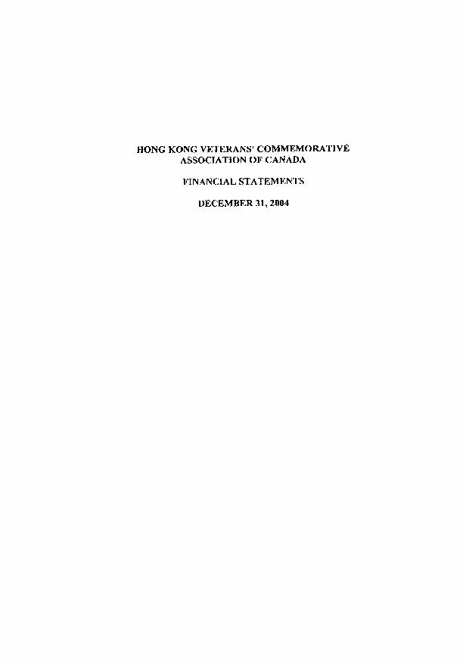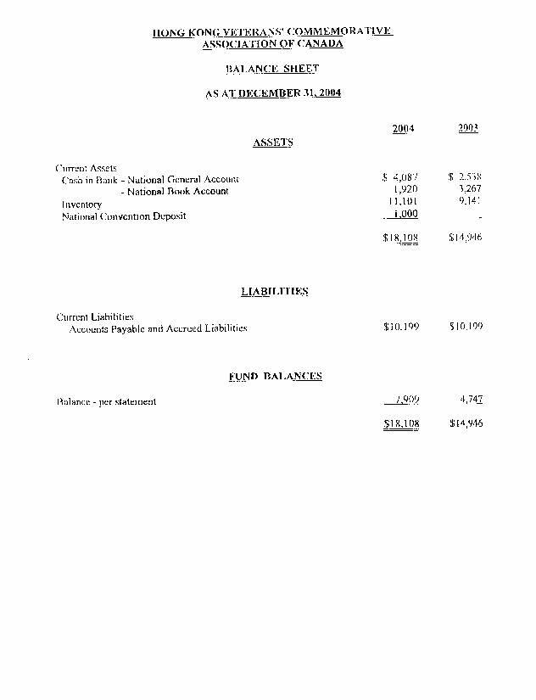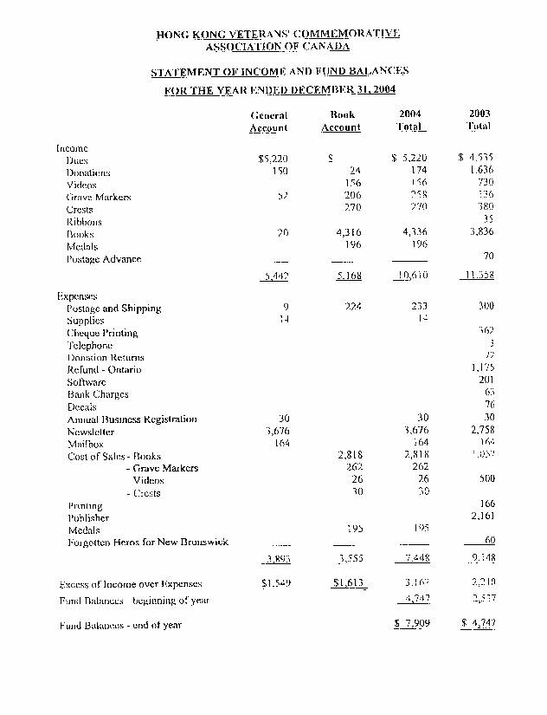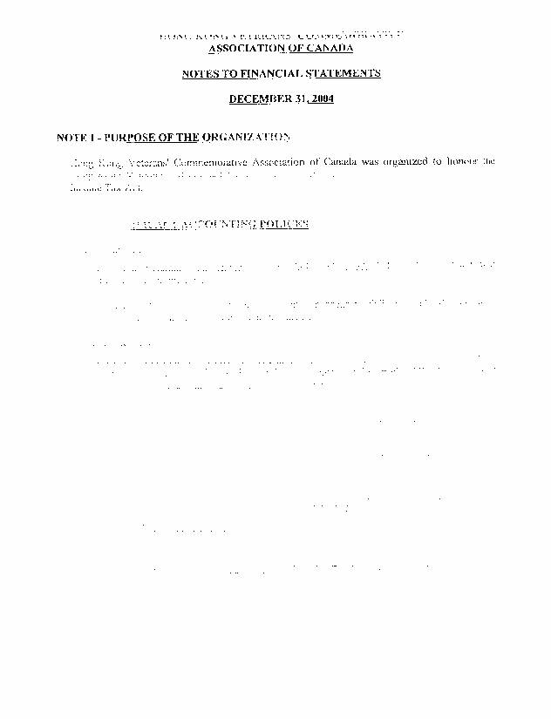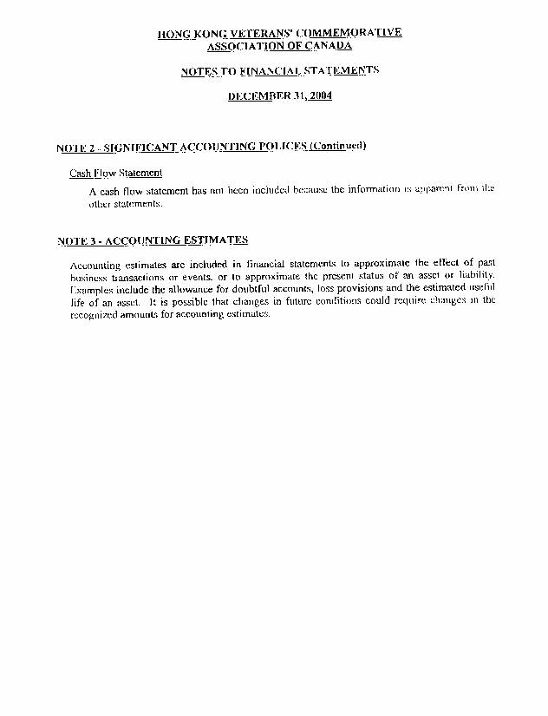
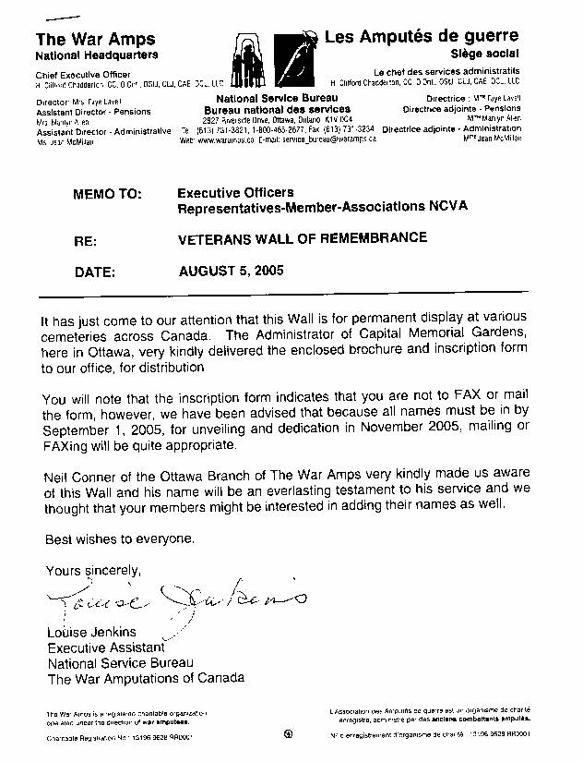
National President’s Report to the 2005 Convention

I sincerely thank Pat Turcotte, Derrill Henderson and their committees and VAC for all the work and efforts that went into this convention – Great Job!!

Thank you to Mike Babin for doing the Protocol and for being the protem Secretary – greatly appreciated.

When I was elected in 2001 to be your President, I was unsure of where the Association was going. I knew we had a good beginning with the previous Executive under the leadership of Derrill Henderson but the question was, what were we going to accomplish in the next few years. As I began this report I was amazed and thrilled to see how we have progressed.
I have had the privilege of working with some amazing people over the last 4 years and it has been a labour of love for all of us. The items that I list are all significant signs of our growth and establishing a national entity:
- The widows and veterans were made Honourary members of our Association; this will
ensure their welfare when the sunset clause is in effect.
- We established a presence through our correspondence by creating uniformity in our stationery materials.
- We gained recognition in the community by assisting our veterans, with/and participating in, Remembrance services - also with our own remembrance of VJ Day and Christmas Day.
- As we had our own crest, we established a voluntary mode of dress that is worn by members of the Executive. Now we have a member’s lapel pin, similar to the crest, that is another mode of recognition.
- The HK membership decal evolved to include the HKVCA; recognising the partnership we share with our veterans.
- Our charitable status was obtained after a lot of hard work and will aid us in gathering funds for our projects.
- A concerted effort was made to have the veterans relate their experiences so that future generations would have a sense of what war was about – some are on our website and some were sent to the Memory Project.
- We initiated Polices and Procedures to clarify the bylaws and to govern ourselves more efficiently.
- Our members have invaded the education field armed with the curricula that has been developed in BC and ON. They have manned displays promoting the Battle of Hong Kong to ensure the members of ‘C’ Force are not forgotten. ON region are assisting Port Perry school in a pilgrimage to HK later this year.
- Our website has grown and matured to be a living testimonial to ‘C’ Force – thank you to all who have contributed to this and to those who have worked on the site. Other members have created websites in honour of their family member to increase our knowledge of the HK events – some of these are linked on our site.
- The National Executive hold monthly meetings in the secure chat room that has been created on our website. From BC to the Maritimes – we are able to conduct business, share reports and plan for the future without leaving our computers.
- AB/SK Region was formed - thanks to the hard work of their HK Vet Executive and our dedicated members in that region.
- Many members and veterans have assisted various media people in producing books and films on the Battle of Hong Kong that supports the goals of our Assn.
- Any request for information that comes through our website is answered – many with more information than was required – thank you to all who have assisted in this.
- The VIP program for widows was extended - thank you to our patron, Cliff Chadderton and to the HKV Executive that pushed this through.
- Canadian Culture Online Project, Canadian Heritage – hopefully the proposal will be accepted so it can be used to digitize the VAC video tapes from 1997.

These accomplishments have been added to existing projects like:
- Our national newsletter that is sent 2 x/ year to communicate to all members the progress of the Assn.
- There is a promotional committee that looks into commemorative items to use in promoting the Assn and our HK vets – suggestions of items are always welcome.
- Our book committee tracks the progress of written materials that our Assn handles, related to the Battle of Hong Kong. This is a big dollar item but it is very necessary to supply these resources to our students and educators - also family members that may want to learn more of the events.

These projects are all implemented and coordinated by the National and Regional Executives with the objective to promote an awareness to all Canadians of the efforts of the men and women of ‘C’ Force. I commend all the Executive and members for their dedication and commitment to the Assn and the projects that we embrace.

As we proceed into the future we need to fortify our regions with more activity – increasing membership (the goal is to have a family member for each of the men/women of “C” Force); education, our future depends on our youth becoming involved and they will only do that if they understand why they should be involved; more awareness through ceremonies and festivities; building bridges with other veteran ass’ns will add to our strength. A person’s involvement is dependant on their circumstances and commitment – you can do a little or a lot – it all counts in the long run.

I sincerely thank the members of the Executive that I have worked with over the last 4 years. They say that the whole is as good as each part and on the whole I believe that we have worked well together – and although we have not always agreed on things – that is a good thing – we would become very stagnant if we were not doing checks and balances throughout our business. I have truly enjoyed meeting, working and sharing time with all of the members. I thank you for the privilege of serving as the President and hope to be around a few more years to help in any way that I can. God bless you all!
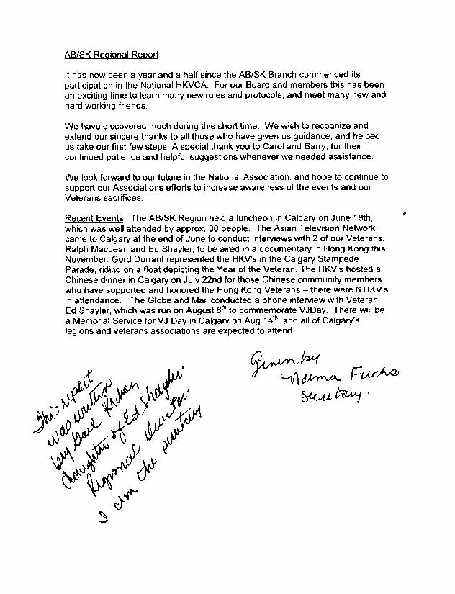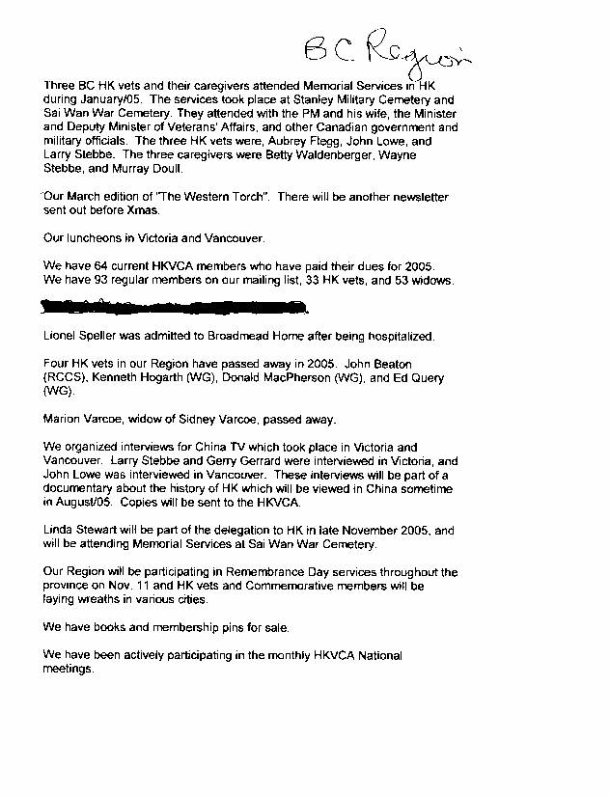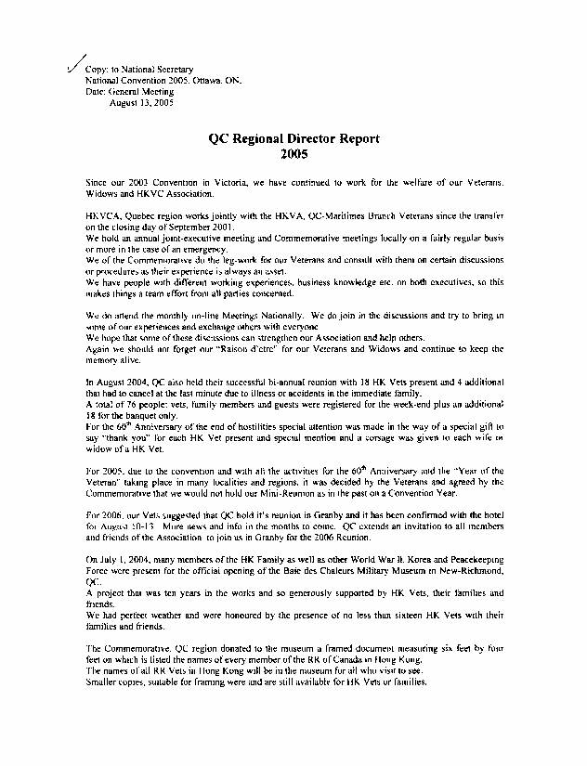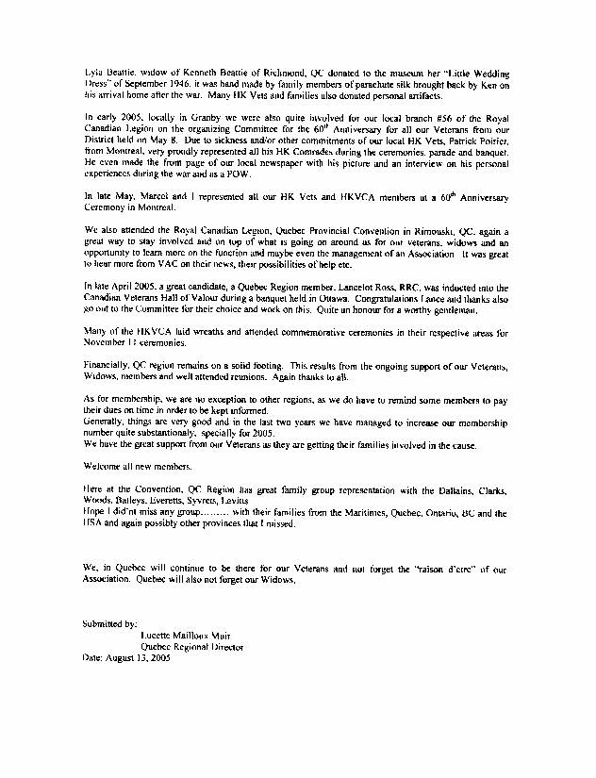
Ontario Region Report: Annual General Meeting
National Convention, Aug.13, 2005

Much of the Ontario Region’s activities in the last few months have centred around preparations for the National Convention. Four members of the Ontario Executive have been able to be involved in the monthly meetings held in Ottawa. Only one of those four, Sandi Cameron, is an Ottawa resident. Sandi, our Regional Treasurer, played a pivotal role in a number of aspects of the Convention preparations. She was not only in charge of the Registration, but acted as Treasurer for the Ottawa Committee which had been formed to lay the groundwork for the Convention itself.

The others involved included Sylvia Mason, who lives in Keswick. She became the Secretary of the Ottawa Committee, and kept us all on track with her charts updating the many responsibilities of various committee members. Mike Babin, from Toronto, attended early meetings, and Pat Turcotte, from Mississauga, assumed responsibility for finding the volunteers to cover the 200 plus hours where help would be needed. Lori Smith, our Regional Secretary, who lives in London, was unable to attend the Convention. However, she was assisted by Dorothy Sauson in her preparations for the Remembrance Protocol ceremony. Monthly meetings began over a year ago, and for the Ontario Executive involved, at least one member, and most times two, travelled to Ottawa to be part of the continuing discussions.

The many other activities of the Ontario Region have included introducing the Ten Lessons, titled “Canada in Hong Kong: 19412 1945 The Forgotten Heroes” to various interested groups around the country. Carol Hadley, in Manitoba, has been responsible for considerable interest in the schools in Manitoba. The New Brunswick Department of Education, having seen copies of the lessons, decided to develop a pilot project for their Grade Nines across the province, by which they would determine whether the Ten Lessons would become part of the curriculum. The success of the project would mean that they would also want to order copies of the French translation of those lessons. We will be in touch with the Minister shortly to let them know that the French Translation’s completion is imminent, and that copies of the translation will soon be available.

The attempt to arrange for a French translation of the Ten Lessons has resulted just recently in the Canada Remembers Division of Veterans Affairs making a decision to fund through their Partnership programme the cost of hiring a translator. They will also provide the additional copies required to introduce the French translation, as well as the English version, to educational institutions across the country. Through this effort, we will be able to create more interest and awareness in various school boards, and, in turn, in the individual teachers themselves. We do reach more and more teachers in Ontario every year by attending their annual conference, the Ontario History and Social Science Teachers Association Conference (OHASSTA), and this year we do expect to have the French translation to show them.

We have been producing two Ontario Region Newsletters per year for four years now. Sylvia Mason and Tim Hodkinson took over the publishing, printing and mailing of the June issue just recently, and did an excellent job. They intend to work on the newsletter for December 2005, and, hopefully, will want to continue with issues in 2006.

Mike Babin has been successful in organizing a trip to Hong Kong in December for all interested HKVCA members and friends. At last count, there were 25 people going, and there are still openings available to those interested. Several veterans will be there, three confirmed at the moment and possibly three or four more that are planning to attend. It should be a very special situation, as the visit will be timed to connect with the 200 plus students going on their own pilgrimage to honour the Hong Kong veterans. Both groups will be present at special ceremonies to be held at Sai Wan Cemetery in the first week of December.

There will be many things to attract you at the Convention. One of the things all registrant should be sure to do is visit the Memorabilia Room. Ron McGuire and several other Ontario HKVCA members have special exhibits that you won’t want to miss. Young people in particular will want to go to the Blogging room set up by Veterans Affairs so that they can document some of the experiences they have had in being part of the Convention. One thing that certainly must be mentioned is the huge contribution, financially, and in personnel, made by Veterans Affairs. We do thank them for that, as VAC has helped ensure the success of this very special event.

There is one last item to mention relative to the Ontario Region. We will be sending out the Call for Nominations in September for the election which will be held later on in the fall. We urge the Ontario Region members to consider getting involved by letting their names stand, as we want to continue to grow as a Region, and to make our contribution to the life of the HKVCA organization as healthy a one as possible.

Submitted by:

Pat Turcotte
Regional Director
HKVCA, Ontario Region

