The Torch

Quebec Region
Volume 5 Number 3 September 2006

Word from Phil Doddridge, veterans spokesman
GRANBY
Once again Lucette and Marcel outdid themselves with a reunion and party that will be recorded with the best of them.
There were twelve Hong Kong Vets in attendance, although Pat Poirier had to leave after the first day.
Others were, Ossie Clark, Austin and Eric Batley, Bruce Cadoret, Paul Dallain , Flash Clayton, Bob Olscamp, John Levitt, Bill Doull, Dempsey Syvret, and Phil Doddridge.
The usual party at the cabane a sucre was a huge success.Marcel and Lucette entertained in cowboy costumes and a

HKVCA Administration
Philip Doddridge
HKVA, National President
Veterans’ Spokesman
Lucette M. Muir
Quebec Regional Director
Allan Marshall
Treasurer
Debbie Batley-Everett
Secretary
Marcel Mondou
Deputy Director
Membership Chairman
Renay Perrier
Deputy Director
- - -
18 rue Barre
Canton de Granby, QC J2H 2E6
Tel.: 450-375-7439
group of line dancers put on a show for us.
And the food! French-Canadian all the way! My calorie scale went up several notches!

PAT POIRIER
I had a call from Pat last evening. He has had to move into a senior’s residence. I am sure he would appreciate hearing from you. His new address is: Room 400, Residence Soleil, 7650 Lespiney Street, Saint Leonard, QC, H1S 2Y6, Tel: 514-255-2171

JAPANESE SURRENDER
In this morning’s (September 2nd)CBC radio news there was an item about the formal surrender of Japan and the signing signing ceremonies aboard the battleship Missouri.
Because Canada had been represented as a combatant in the Pacific Theatre, (that was us) a Canadian , Colonel Lawrence Moore Cosgrave, was assigned the duty of signing for Canada.
In his haste to have his name recorded in history, he signed his name in the wrong place, below the line.
This caused others signing after him to place their signatures also in the wrong place.
So, his fifteen minutes of fame was marred by a stupid blunder.
It was later said that he was suffering from a severe headache and that he was blind in one eye,
which caused him to make the error….. .
I copied the following account from the internet. There was no author named for the article.

The Japanese Formal Surrender

World War II officially ended on August 14. (The day Japan announced the surrender) but it wasn’t signed until September 2nd of 1945. The signing occurred on the battleship Missouri in Tokyo Bay. The same flag that hung in Washington on December 7, 1941 was now waving on this tremendous battleship.
Nine Japanese delegation members dressed formally and were led onto the ship. General Douglas MacArthur, head of the Pacific War, was there on the battleship ready to sign the document. Foreign Minister Mamoru Shigemitsu was the first to sign the surrender. General Yoshijiro Umezu of the General Staff signed the document for the Japanese armed forces and the Emperor.
General MacArthur was next to sign. He was accompanied by General Jonathan M. Wainwright, and Lieutenant General Arthur Percival. The two were recently rescued from P.O.W. Camps. Admiral Chester W. Nimitz, General Hsu Yung Chang, Sir Bruce Fraser, and Lieutenant General K. Derevyanko also signed the surrender.
Over 400 Superfortresses flew over Tokyo, and later some 20,000 troops were ashore in Japan. President Roosevelt claimed September 2nd as V-J Day. Emperor Hirohito of Japan ordered his people to take in the Americans.
People all over the world celebrated. The war was over. After nearly six years, it was finally over! One of the most disastrous, innovative, and destructive wars was over. There was finally peace.

REUNION IN FLORENCEVILLE

Bob Barter and I travelled to the Maritimes-Gaspesian reunion.
It was a very nice and quiet reunion. Six veterans were in attendance : Henry Lyons, Bill MacWhirter, Graham Boudreau, John Duguay, Bob and I.
Those people are great for us.

That’s all for this time.
Be good to each other, and may God Bless.
Philip

Word from Quebec Regional Director Lucette M.Muir
Greetings to all.
Here we are again to say hello and hope you are all well and enjoyed a nice and joyful summer. Today it feels like fall is already here with it’s cool misty weather. Already the leaves are changing their colours. Nature is fast changing. We will still have beautiful days before the cost and winter sets in.
Since our last newsletter, I attended our monthly on-line national meetings. In July we held our annual joint-executive meeting in New Richmond, QC. Present were Philip Doddridge, Henry Lyons, Arnold Ross, Jean Paul Dallain, Bob Barter, Richard Keays, Marcel Mondou, Allan Marshall, Debbie Batley-Everett and yours truly. The meeting went very well. As usual much was accomplished. Following the meeting the spouses joined all the executive members for a lovely meal and a friendly chat. A good time was had by all.
On August 4, Marcel and I travelled to New Richmond, QC for the internment of Lancelot Ross in his hometown of Hopetown, QC. At the funeral parlour was held a small service and prayers followed by an eulogy. At the cemetery HK Vets Philip Doddridge, Bob Barter, Arnold Ross, Jean-Paul Dallain and Henry Lyons and local Veterans marched to the grave site where prayers were said followed by a poppy drop.
Since the Reunion we took things easy for a few days. The reunion will be reported on later in the newsletter.
That is it for this time, take care.
Lucette

Last Post
At this time we are sad to report the passing of more of our comrades. Some of these names may have been mentioned elsewhere, but in the interest of keeping the record straight, they are mentioned here. In no particular order: Alfred S. Wagner WG, Joseph N. Leblanc RRC, Peter Anthony Gelley WG.
Widows: Rita T. Burton widow of Keith Burton, Pauline Sweet widow of Royce (Bud) Sweet RRC, Rhona Muir wife of William “Bill” Muir WG, Margaret Trasiewick widow of Joseph E. Trasiewick, Thelma Cole widow of Gordon A. Cole WG, Monique Russell widow of Albert Russell RRC, Ruth Kellas widow of W.A. Kellas WG.
They shall grow not old; Age shall not weary them nor the years condemn. At the going down of the sun and in the morning.
WE WILL REMEMBER THEM!
Our thoughts and prayers go out to all families in this time of great sorrow.
Sick Parade
Our thoughts go out to: Edwina Doddridge who is back home after a few days in hospital, Laura Ross is recuperating since her surgery, Richard “Dick” Keays is back home after 10 days in hospital with pneumonia, Fred J. Mason with a nasty fall, Pat Poirier is feeling much better as he is getting more rest since his move to his new Senior Home, Bob Olscamp is doing much better in his new Senior Home, Rosa Arbour has been hospitalised for the last 6 months.
Other veterans and widows have been under the weather with different ailments and possibly more that we did not hear about.
A friendly note or call to these people is very “good for the moral”.
Having your love ones near you has a way of helping things.
Our thoughts and prayers go out to all our sick.
Take care,
Humour
NEWS REPORT
A certain private school recently was faced with a unique problem. A number of 12-year-old girls were beginning to use lipstick and would put it on in the restroom.
That was fine, but after they put on their lipstick, they would press their lips to the mirror leaving dozens of little lip prints.
Every night the maintenance man would remove them and the next day the girls would put them back. Several memos were posted about this.
Finally the principal decided that something had to be done… She called all the girls to the bathroom and met them there with the maintenance man. She explained that all these lip prints were causing a major problem for the custodian who had to clean the mirrors every night.
To demonstrate how difficult it had been to clean the mirrors, she asked the maintenance man to show the girls how much effort was required.
He took out a long-handled squeegee, dipped it in the toilet, and cleaned the mirror with it.
Since then, there have been no lip prints on the mirror.
There are teachers, and then there are educators.
Happy Birthday
October: Eric Batley, Rena Cadoret, Lucette M.Muir, Bernice Simons.
November: Walter Gray, Geoffrey Knowles, Patrick Poirier, Rollande Miller.
December: Bruce Cadoret, Veronica Hunt, Allan Marshall, Jocelyn Vincent-Roy.
A late Birthday mention for Jean Gray for August 10 and John Levitt on September 29 for his 91st.
Wedding Anniversary
A quite period, it seems.
A late Wedding Anniversary wish for Jean and Walter Gray from Vancouver who celebrated their 65th on August 26.
Happy Birthday
Happy Anniversary and
Best Wishes to all
(If we have your birthday month, all the HK Family would know of your special day and even send you their personal wishes).
Correspondence
In no particular order, received correspondence or calls from: Mitzi Ross, Bonny Vincent, Flash and Jessie Clayton, Laurette Daigle, Joan Gillies, Lillian Brunet, Marge Dwyer, Rita Bujold, Mavis Frost, Desmond Irving, Renee Giard.
Donations
In no particular order: Arnold Ross, Desmond Irving, Robert Olscamp, Elsie Stoddard, Elizabeth Firth, Annie Nolan, Charles Dallain, Mavis Frost, Nancy Welsh, Dempsey Syvret, Barbara Hardy, Joan Gillis,Clifford & Etta McDavid, Douglas B. Rees, Murray Doull, Bruce Cadoret, Renald Paiement, Shawn Batley, Richard & Nellie Keays, Fred J. Mason, Rita Bujold.
Many Thanks to all of you for your participation with your donations for the welfare of your Association.
Membership
Greetings to all.
My responsibility is still encouraging you to keep up with your membership by sending us your $ 15.00 each calendar year.
Again I would like to ask you to check your membership card and……. if it is marked 2006… you are up to date, if you do not have it… you STILL HAVE TIME TO PAY YOUR 2006 MEMBERSHIP DUES. I am sure this is only an oversight on your part... (HK veterans and widows do not pay). This condition will affect continuing to receive The Torch as well as the National Newsletter. I’m confident that you will come forward very shortly.
2006 is fast coming to a close and 2007 is on our doorstep so take the time to think about your 2007 membership dues. Take care of that business early and you will be able to forget it and not worry about it for an other year.
If you are moving in the near future or if you have been blessed by Canada Post making their changes or City re-organizations (without you moving from your home) PLEASE DO NOT FORGET TO LET ME KNOW of your new address (changes in these cases are not made automatically) as you might experience delays or simply may not receive the delivery of your next newsletters, correspondence etc.
At this time I would like to welcome a new member into our Quebec Family, Carole Olscamp from Beloeil, daughter of Robert Olscamp, Darin Bennett from Blackstock, ON grandson of the late Clarence Hunt RRC and Eva Hunt of Lennoxville. Welcome Darin.
If you have any questions on membership, feel free to call or write to our Granby address or by e-mail at mondoumarcel@videotron.caThank you all for your support and great interest in our association.
Marcel

November 11, 2006
Again that time of year is fast approaching. November 11th is a year long activity.
Why wait for November 11th to say “Thank you to a Veteran” for what we today sometimes take for granted
“OUR FREEDOM”
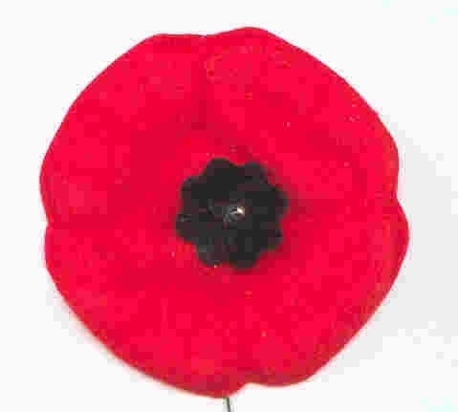
Take the time to remember! Take part in your local activities for the Armistice Ceremonies.
“THANK A VETERAN!”

FRANK THE WAR HERO
A true story adapted and presented at a 2005 Remembrance Day assembly at Royal Oak Elementary in St-Hubert, QC
I want to tell you a story about a war hero. His name was Frank and he was born in Poland in 1900. When he was 16 years old, he was forced to fight for his country during World War 1. Luckily, he made it out alive but many of his friends did not. He hoped that he would never have to fight in another war again and that people would just learn to live peacefully.
But then, when Frank was 39 years old, he decided to fight for his country again in World War 2 because a very bad man named Hitler was trying to make the world a terrible place. Soldiers from different countries including Canada all did their best to stop him. Frank was captured by the enemy army and they brought him to a prison in a place called Siberia. It was very cold there and there was no food. By some miracle, Frank escaped and went alone across the ice desert and through the dark forest where he was bitten by thousands of mosquitoes. He eventually got to a field where bombs were falling. He wanted to hide in a trench, which is like a hole dug in the earth for soldiers to hide in, but there was a wild pig in it. Frank was always a lucky man though, so a bomb fell into the trench and killed the pig instead of him! He ate the pig for supper and so he didn’t die of hunger either.
Finally, in 1945, the war was over. Frank went back to Poland to find that his family was gone and his house had been burned down. To make matters even worse, his village didn’t even belong to his country anymore so he was kicked out. He was saved by the British army and brought to England. That’s where Frank met Anna. Her family had also died in the war. Frank and Anna got married and came to Canada. They built a house and had a baby girl named Lucy.
Lucy is my mother and Frank and Anna were my grandparents. If it wasn’t for soldiers like Frank who survived, a lot of us would not exist. And if it wasn’t for all the soldiers who fought for good rather than evil, those who lived and those who died, maybe mean people like Hitler would succeed in making our world an awful place.
Frank died in 1999. He was almost 100 years old. THANK YOU FRANK AND MAY YOU REST IN PEACE.
Humour
A man and his wife are dining at a table in a plush restaurant, and the husband keeps staring at an old drunken lady swigging her gin as she sits alone at a nearby table.
The wife asks, “Honey do you know her?”
“Yes,” sighs the husband, “she’s my ex-wife. She took to drinking right after we divorced seven years ago, and I hear she hasn’t been sober since.”
“Good Grief!” says the wife, “Who would think a person could go on celebrating that long?”
Quebec Reunion 2006 Yes another Reunion is over and another year fast coming to a close.
Thanks to all, the Reunion was a success. In attendance we had eleven Veterans, Widows, Family members and Friends of the HK Family for a total of eighty three. Four Vets cancelled and one had to leave early due to sickness or accident.
Six of our Provinces were represented by Veterans, Widows and/or family members from as far as BC, Sask. and Manitoba. Of course Ontario, NB and Quebec were well represented.
On Friday we held a Joint-General Meeting in the morning and later in the day a real Quebecois Meal, music and country line dancers performed for us. Many guests joined the dancers for their try at it and did very well I must say. Great fun was had by all.
On Saturday morning we held our Commemorative Ceremonies, Parade and Flag deposit for our deceased Vets.. Philip Doddridge layed the HK wreath for all Vets, Lucette Muir for the Commemorative Association, Renee Giard for the Widows. All Vets each deposited a small flag for each of their fallen Comrades since our last Reunion, Patricia Maltman from Winnipeg for all Winnipeg Grenadiers and Family members for their Dad’s. The HK Banner was carried by John H. Russell, OMM, CD from Kingston ON in respect for his Dad deceased in 2005. Murray Doull from Maple Ridge BC also gave us a great last minute hand to carry the Canadian flag.
The banquet, drawings and dancing closed the day.
As usual Philip Doddridge also had a few words to say to all his Comrades and all guests. Yours truly thanked everyone for their presence and their support for the last two years and confidence for the next mandate. As mentioned earlier Lucette and Marcel organized the reunion but not without the help of the complete executive and friends. Katherine Marshall, Debbie Batley & Lucille Marquis with the preparation of gifts, decorations etc. Heather for the posters, Larry Everett with his uniform for the ceremonies etc. We cannot forget Dillon Everett our future member on training for mixing up our drawing tickets ouf! Renay Perrier Host of the hospitality suite etc. Allan Marshall our social MC and for the Commemorative Ceremony and prayers and legion members Michael Laflamme as flag barer and Bob Perrier for his help where needed. Thank you all. Yours truly also had special words of thanks to the 2006 Reunion Committee’s “Honorary President” Oswald Clark for his special effort, due to his health problems, to attend the Reunion.
The winners of our ticket draw for the Reunion were:
3rd prize, Eili Viner of Calgary AB
2nd prize, Raymond Quirion from Perce or Montreal QC
1st prize, Veronica Hunt from l’Ange Gardien QC
Congratulations to all the draw winners and all the winners of the door prizes.
Sunday morning we had a “Farewell” breakfast as people started to think about their trip back home with good memories and sad goodbyes.
Great camaraderie and catching up on all the news etc was shared by all. Thank you all how helped to make this Reunion a success by your participation.
Till we meet again for the next one. Date and place to come.
Convention 2007
The Alberta/Saskatchewan Region of the HKVCA has graciously accepted to host the next National HKVCA Convention on August 15-19 2007 in Calgary. Things will take place at the Hyatt Regency Hotel, 700 Center St. S., Calgary, AB.
We will keep you informed as things develop.
See you then.
Humour
Military Humour
Sitting stiffly side by side on a long commercial flight. After they’re airborne and the plane has levelled off, the man in the window seat abruptly says, distinctly and confidently, in a loud voice, “Admiral, United States Navy, retired, married, two sons, both surgeons.”
After a few minutes the man in the aisle seat states through a tight lipped smile, “Admiral, United States Coast Guard, retired. Married, two sons, both Judges.”
After some thought, the fellow in the center seat decides to introduce himself. With a twinkle in his eye he proclaims, “Master Gunnery Sergeant, United States Marines, retired. Never married, two sons, both Admirals.

An old man, a boy & a donkey were going to town. The boy rode on the donkey & the old man walked. As they went along they passed some people who remarked it was a shame the old man was walking & the boy was riding.
The man and boy thought maybe the critics were right, so they changed positions.
Later, they passed some people that remarked, “What a shame, he makes the little boy walk.”
They then decided they both would walk! Soon they passed some more people who thought they were stupid to walk when they had a decent donkey to ride. So, they both rode the donkey.
Now they passed some people that shamed them by saying how awful to put such a load on a poor donkey.
The boy and man said they were probably right, so they decide to carry the donkey (hmm)… As they crossed the bridge, they lost their grip on the animal and he fell into the river and drowned.
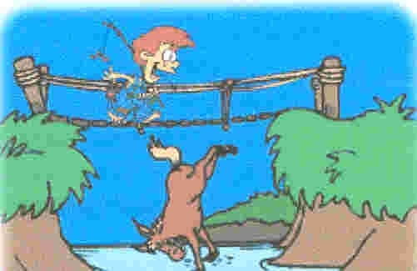
The moral of the story?
If you try to please everyone, you might as well…
Kiss your ass goodbye!
Book Corner
The Royal Rifles of Canada in Hong Kong by Grant Garneau is still available from your Quebec Region. It is for sale at the cost of $ 50.00 per copy, including shipping and handling. Just contact Lucette with your order and cheque.
Other books are also available through your National Address.
Nominal Roll
Plastic-coated copies 12” x 19” of the Nominal Roll of the Royal Rifles in Hong Kong are available for sale at the cost of $ 10.00 including postage. Make your cheque payable to HKVCA,QC for the number of copies required and mail to HKVCA, 18 Barre, Granby, QC, J2H 2E6.
Maple Leaf Broach

Yes, we finally received our copies of the Maple Leaf Broach. It is available through your regional address for $ 25.00 including handling and shipping costs.
It is the same size (1”x1 ½”) as the originals but it is silver in colour only with the regular coloured HK logo.
Please make your cheque x number of broaches, payable to HKVCA QC and send to your Quebec address.
Quebec Region Polo
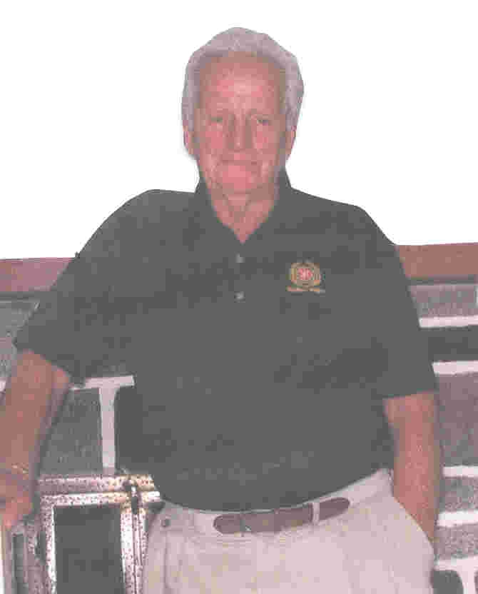
Quebec Region has designed a new polo shirt. It was worn with beige slacks by all executive members for the first time during our recent Reunion.
It is Hong Kong green in color, a light knit, short sleeves with the HKVCA logo and Quebec Region embroidered in it’s original colours (no pocket).
It was quite a hit during the Reunion and we decided to offer it to all members. It is available in sizes S, M, L, XL at the cost of $ 25.00 including shipping. Mail your cheque to the Granby address and payable to HKVCA QC.
Call for Elections 2006
A “Call for Elections” was out for 2006 for Quebec Region. We thank everyone who took the time to vote.
During our Joint-General Meeting it was announced that: the complete committee was Re-Elected and that Renay Perrier was elected as our new Deputy Director. (see front page).
Renay is a very hard working retired individual with very high regards for all veterans. Renay has been very interested in the Hong Kong story for a number of years. He has become a very good friend of the Hong Kong Family. Welcome aboard Renay.

The following made me smile.
An elderly Chinese woman had two large pots, each hung on the ends of a pole which she carried across her neck. One of the pots had a crack in it while the other pot was perfect and always delivered a full portion of water. At the end of the long walk from the stream to the house, the cracked pot arrived only half full.
For a full two years this went on daily, with the woman bringing home only one and a half pots of water. Of course, the perfect pot was proud of its accomplishments. But the poor cracked pot was ashamed of its own imperfection, and miserable that it could only do half of what it had been made to do. After two years of what it perceived to be bitter failure, it spoke to the woman one day by the stream. “I am ashamed of myself, because this crack in my side causes water to leak out all the way back to your house.” The old woman smiled, “Did you notice that there are flowers on your side of the path, but not on the other pot’s side?” “That’s because I have always known about your flaw, so I planted flower seeds on your side of the path, and every day while we walk back, you water them.” “For two years I have been able to pick these beautiful flowers to decorate the table. Without you being just the way you are, there would not be this beauty to grace the house.”
Each of us has our own unique flaw. But it’s the cracks and flaws we each have that make our lives together so very interesting and rewarding.
You’ve just got to take each person for what they are and look for the good in them.
SO, to all of my crackpot friends, have a great day and remember to smell the flowers on your side of the path!
Grand Kids are great
I didn’t know if my granddaughter had learned her colors yet, so I decided to test her. I would point out something and ask what color it was. She would tell me, and always she was correct. But it was fun for me, so I continued. At last she headed for the door, saying sagely, “Grandma, I think you should try to figure out some of these yourself!”
----My grandson was visiting one day when he asked, “Grandma, do you know how you and God are alike?”
I mentally polished my halo while I asked, “No, how are we alike?”
“You’re both old,” he replied.

Happy
Thanksgiving from our families to Yours
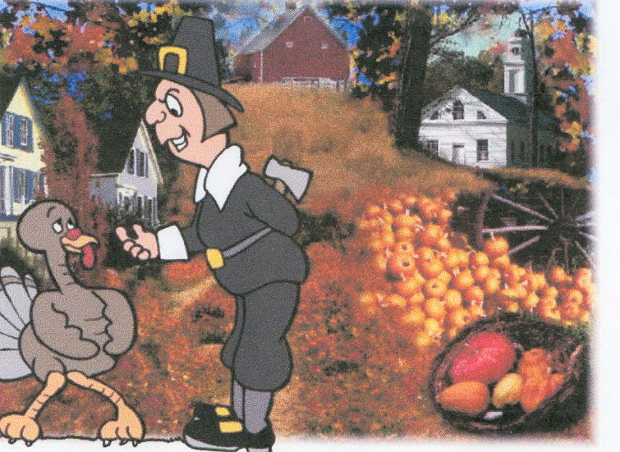
Your Executive
That is it for this time.
Take care,
Till next time – December 2006.
Lucette

